**Challenge 7**

[www.pythonchallenge.com/pc/def/oxygen.html](http://www.pythonchallenge.com/pc/def/oxygen.html)

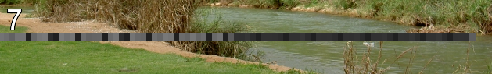

This picture is not very big. Shows a river bank scene with a shades of gray bar across the middle. Maybe this is an image processing type challenge. The page title is ‘smarty’. Don’t see anything in the source code and clicking stuff doesn’t do anything.

It turns out that smarty is a python thing: **a template engine for PHP, facilitating the separation of presentation (HTML/CSS) from application logic**

But can’t see how that applies here. Since I’ve been working on opencv for a while, plan is to get that bar in the picture and see if the pixel colors translate to anything. I **cv2** for this type of thing. The pixels are in blue / green / red order. The image is put into a numpy array and can be manipulated there.

I put the image into pcpaint (I’m old school) and drew white lines around it so I could pick out the gray bar. It appears to be on lines 43-51. The blocks are 7 pixels wide.

Then made a list of the first values from the pixels (b, g, r), and made a string. This gives the message: smart guy, you made it. the next level is [105, 110, 116, 101, 103, 114, 105, 116, 121]

Converting those numbers to a string gives ‘integrity’ which reveals next challenge.